분석 결과  
  
작성자 : 양지한  
  
1. 분석 대상

* 인스타그램에서 해시태그 “#싱가폴”로 검색하여 100개의 이미지를 저장한 후   
  그 이미지를 Inception 방식으로 어떤 장소인지를 분석하는 테스트 진행

2. 이미지  
 - “2018-09-20-이미지 데이터” 폴더에 올려진 이미지를 대상으로 진행함

3. 분석 방법  
 - 구글의 Inception 분석 방식 사용  
 - 별첨 자료 참조

4. 분석 결과

① 1번 이미지 분석  
$ python predict.py testimage/insta/39135435_281194632485297_3044237885450319156_n.jpg

/Users/yjh/anaconda3/lib/python3.6/site-packages/h5py/__init__.py:34: FutureWarning: Conversion of the second argument of issubdtype from `float` to `np.floating` is deprecated. In future, it will be treated as `np.float64 == np.dtype(float).type`.

from ._conv import register_converters as _register_converters

2018-10-03 21:28:46.450021: W tensorflow/core/framework/op_def_util.cc:355] Op BatchNormWithGlobalNormalization is deprecated. It will cease to work in GraphDef version 9. Use tf.nn.batch_normalization().

2018-10-03 21:28:46.642837: I tensorflow/core/platform/cpu_feature_guard.cc:141] Your CPU supports instructions that this TensorFlow binary was not compiled to use: AVX2 FMA

=== 예측 결과 ===

marina bay (99.23%)

lotte tower (0.14%)

gwanghwamun (0.05%)

epel tower (0.29%)

universal studio (0.29%)

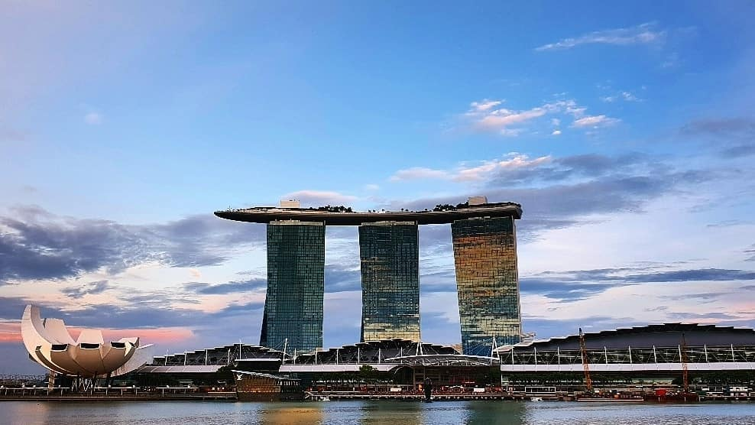  
(분석 대상 사진 : 39135435_281194632485297_3044237885450319156_n.jpg )

② 2번 이미지 분석

$ python predict.py testimage/insta/39975806_877153602482956_1718709380734939870_n.jpg

/Users/yjh/anaconda3/lib/python3.6/site-packages/h5py/__init__.py:34: FutureWarning: Conversion of the second argument of issubdtype from `float` to `np.floating` is deprecated. In future, it will be treated as `np.float64 == np.dtype(float).type`.

from ._conv import register_converters as _register_converters

2018-10-03 21:29:32.045273: W tensorflow/core/framework/op_def_util.cc:355] Op BatchNormWithGlobalNormalization is deprecated. It will cease to work in GraphDef version 9. Use tf.nn.batch_normalization().

2018-10-03 21:29:32.232451: I tensorflow/core/platform/cpu_feature_guard.cc:141] Your CPU supports instructions that this TensorFlow binary was not compiled to use: AVX2 FMA

=== 예측 결과 ===

marina bay (99.24%)

lotte tower (0.40%)

gwanghwamun (0.09%)

epel tower (0.05%)

universal studio (0.21%)  
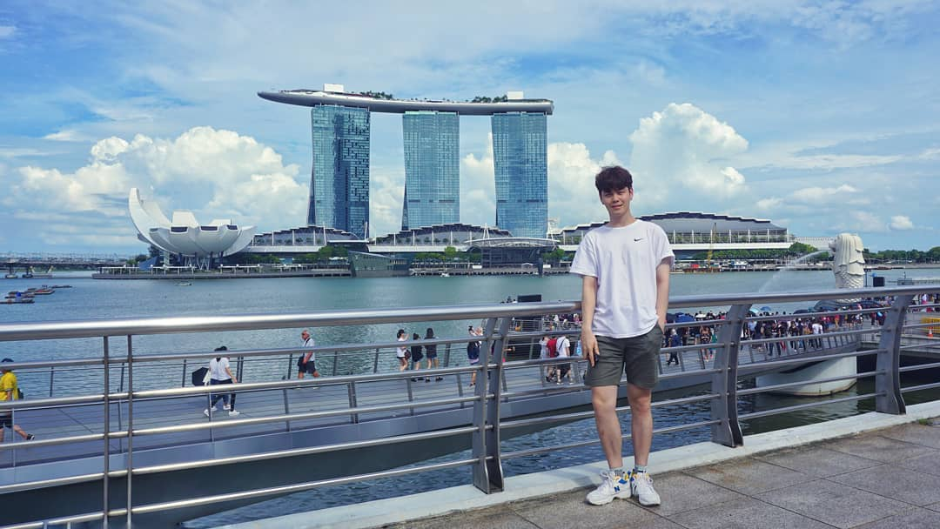  
(분석 대상 사진 : 39975806_877153602482956_1718709380734939870_n.jpg )